Welcome to Kranz Junior High School! My name is Mrs. Birmingham, and I am delighted to be your science teacher this year.

Content Focus

Fall Semester
1st Nine Weeks | Lab Safety and Scientific Inquiry.  Organisms and Environment: Interdependence and Competition in Ecosystems, Effects of Short and Long Term Environmental Changes, Human Dependence on Oceans, and Biodiversity.  Matter and Energy: Flow of Energy through Living Systems, and Compare Metals, Nonmetals, and Metalloids.  CBA Week November 16-20
2nd Nine Weeks | Matter and Energy: Density Calculation, Chemical Symbols, Compounds, and Formulas, Structure of Atoms, Protons and Valence Electron, Arrangement of the Periodic Table, Chemical Formulas and Subscripts, Evidence of Chemical Reactions and the Conservation of Mass.  Force, Motion, and Energy: Unbalanced Forces, Speed, Velocity, and Acceleration.

Spring Semester
3rd Nine Weeks | Force, Motion, and Energy: Measure and Graph Changes in Motion, Newton’s Laws of Motion,  Earth and Space: Components of the Universe, Location of the Sun, Electromagnetic Spectrum, Seasons, Day and Night, Lunar Cycle, Effect of Moon and Sun on Ocean Tides, Plate Tectonic Theory, Crustal Features/Plate Tectonics, and Topography.  Pre-STAAR Benchmark March 9-12
4th Nine Weeks | Earth and Space: Convection within the Atmosphere, Oceans and Formation of Weather Systems, and Atmospheric Movement and Weather.  STAAR Preparation, Bridge to Biology (9th grade preparation)  Science STAAR
 | *Changes may occur to the order of the content focus and testing dates*

Assignment Policies: Grading, Homework, Make Up and Late Work
Formative Grades – 50% Summative Grades – 50%
Labs Investigative projects/reports
Class work Quizzes
Tests

Tutoring
Tutoring is by appointment only.

Course Requirements
In addition to proper class attendance, preparation, and completing all necessary course and lab work, each student must:
- Participate in google classroom
- Have a parent/guardian signed Safety Compact on file

Classroom Expectations and Consequences
In order to accomplish a successful year of learning, it is necessary for your child to understand and follow a few basic classroom expectations.
- Do your job, and let everyone else do theirs.
- Be respectful to everyone and everything.
- Settle problems peacefully.
The consequence sequence is as follows and may be adjusted based on teacher judgement and/or student safety:
- Non-verbal signal/proximity/”the look”
- Whispered redirection/post-it note redirection
- Verbal redirection/give choice “You may …. or …”
- Seat change in your classroom/time out in your classroom
- Private conversation away from peers – this is where the relationship piece is so important. Use the CKH 4 questions “What are you doing? What are you supposed to be doing? What do you need to go do now? Can you do it on your own or do you need my help?”
- Send student to buddy teacher for set amount time (no more 15 min.) to complete reflection (4 questions)/call parent (not during class time).
- Write a discipline referral if necessary – students should remain in class and wait for the office to call for them.

Laboratory Activities
As a part of science class this year, the students will conduct investigations that involve physical activity such as jogging or climbing stairs. In other investigations, students will work with or are exposed to plants, animals, or chemicals that might provoke an allergic reaction.

Every student is required to submit a Safety Compact that has been signed by the student and their parent/guardian before participating in any labs.

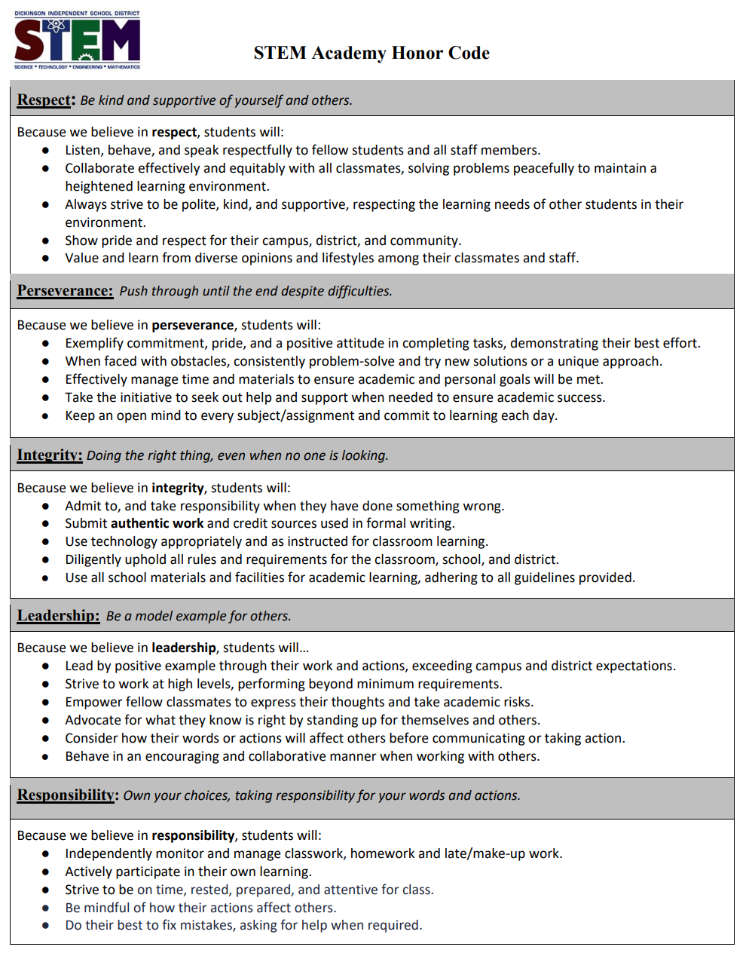

Conclusion
I am looking forward to working with your child this year. You and I are partners with your child in the learning process. If you have any questions, comments, or concerns, please contact me for personal or phone conferences at 281-309-3600. Please keep this letter for your records in case you need to contact me.

Sincerely,
Mrs. Birmingham
STEM 7th Grade Science
cbirmingham@dickinsonisd.org
Kranz Junior High School
(281) 309-3600

